Crystal Structure of Branched-chain amino acid aminotransferase from *Giardia lamblia* ATCC 50803

**Sahil Athalyea, Sri Gaddea, Jan Abendrothcd, Donald D. Lorimercd, Peter S. Horanyicd, Thomas Edwardscd, Peter J. Mylerbd and Craig L. Smithad\***

aDepartment of Biology, Washington University in St. Louis, St. Louis, MO, 63114, United States  
bDepartments of Pediatrics, Global Health, and Biomedical Informatics & Medical Education, University of Washington, Seattle, WA, USA  
cBeryllium, 7869 NE Day Road West, Bainbridge Island, WA, 98102, USA  
dSeattle Structural Genomics Center for Infectious Disease (SSGCID), Seattle, WA, USA

Correspondence email: csmith22@wustl.edu

1. The crystal structure of branched chain amino acid aminotransferase from *Giardia lamblia* bound to pyridoxal phosphate was determined at 2.10 Å resolution.

Giardiasis, caused by *Giardia lamblia,* a flagellated parasitic microorganism that inhabits the small intestine is one of the most prevalent causes of waterborne illness within the U.S. These parasites typically dwell in sparsely frequented bodies of water in the wild but can also be found in public water supplies in addition to pools, spas, and wells. Giardia infection is transmitted by contact between persons, food, or fluids. While antibiotics is a common blanket cure for giardiasis, risks such as antibiotic resistance and adverse side effects can present issues. Consequently, alternatives such as targeting a basic metabolic pathway could provide another feasible treatment for this disease. One potential target pathway might be an essential metabolic enzyme in *G. lamblia* is Branched-chain Amino Acid Aminotransferase (BCAT). BCAT catalyzes the first step of branched-chain amino acid catabolism, which corresponds to the synthesis and degradation of essential amino acids leucine, isoleucine and valine. BCAT transfers an amino group from glutamate to the α-ketoacid of the respective amino acid in the biosynthesis of branched-chain amino acids along with the inverse of this process in amino acid catalysis (Castell, Mille, and Unge 2009). Crystallization of the BCAT structure from *G. lamblia* confirmed that this protein had homodimeric oligomerization. After the homologs were identified, the *G. lamblia* BCAT was structurally aligned with the homologs, and a high level of conservation and structural similarity was shown between the BCATS, especially around the active site. Better understanding BCAT's role in *G. lamblia* may help curb its activity, reducing waterborne illness in the US.

1. ssgcid, Branched-chain amino acid aminotransferase, lateral transfer candidate, *Giardia lamblia*, *Giardia intestinalis*, pyridoxal 5'-phosphate, Structural Genomics, Seattle Structural Genomics Center for Infectious Disease, transferase
2. Introduction

Every year, roughly 200 million people are infected and 500,000 deaths are caused by Giardiasis. These rates of infection differ by country and can range between 2 - 30%, depending on how developed the country is (Hajare, Chekol, Chauhan, 2022). Giardiasis is caused by *Giardia lamblia,* a flagellated parasitic microorganism found commonly in food, soil and other surfaces contaminated by the feces of already infected animals and humans, but the most common source of infection is the swallowing of contaminated water (CDC, 2022). *G. lamblia* primarily exists in two forms, trophozoites and cysts, essentially its active and dormant forms, respectively (Adam 2001). A host is infected when a *G. lamblia* cyst is ingested. Once the dormant cyst reaches the acidic environment of a stomach, it may excyst into trophozoites and inhabit the small intestine (Adam 2001). These trophozoites then multiply in the small intestine, inhibiting absorption of nutrients and causing diarrhea.

An opportunity to target the BCATs of *G. lamblia* may lie during the cyst phase of its life cycle before it enters the human body and begins its metabolic processes involving BCAT. To elucidate how this may be accomplished, an understanding of the *G. lamblia* BCAT must also be achieved. BCAT catalyzes the first step of branched-chain amino acid catabolism, which corresponds to the synthesis and degradation of essential amino acids leucine, isoleucine, and valine. More specifically, BCATs catalyze the transamination of these three branched-chain amino acids (BCAAs) to branched-chain keto acids (BCKAs), which are then used to create branched-chain acyl-CoA intermediates. The metabolism of these BCAAs is also made possible by amine group acceptance by α-ketoglutarate (α-KG) to form glutamate. Pyridoxal phosphate (PLP), the critical ligand in this process hydrolyazes a carbon-nitrogen bond to accept the amine group that is eventually transferred to α-KG. PLP exists in its aminated form pyridoxamine phosphate and its deaminated form PLP within the active site to repeatedly aid in catalysis. Interrupting these underlying processes for catalysis could aid in effectively targeting BCAT.

To better understand the molecular details of BCAT function in *G. lamblia*, we determined its structure using X-ray structural crystallography. We determined the homodimeric structure at 2.10 Å resolution. Afterwards, each monomer was examined in greater detail, and the BCAT was structurally aligned with its homologs. This comparison revealed significant structural similarity and highlighted conservation levels between the *G. lamblia* BCAT and another BCAT found in human mitochondria, suggesting potential targets for inhibition. Building on previously existing research that has explored inhibiting the human form of BCAT, our study investigated potential inhibition mechanisms for the *G. lamblia* BCAT (Gunther et al., 2022). BAY-069, a novel (Trifluoromethyl) pyrimidinedione-Based BCAT1/2 inhibitor and chemical probe shows promise as an effective inhibitor.

1. Materials and methods
   1. Macromolecule production

Text in this section should supplement or complete information provided in Table 1.

1. Macromolecule production information [Style: IUCr table caption; this style applies table numbering]

In the primers, indicate any restriction sites, cleavage sites or introduction of additional residues, *e.g.* His6-tag, as well as modifications, *e.g.* Se-Met instead of Met. [Style: IUCr table headnote]

|  |  |
| --- | --- |
| Source organism | Giardia intestinalis (strain: ATCC 50803 / WB clone C6) |
| DNA source |  |
| Forward primer |  |
| Reverse primer |  |
| Cloning vector |  |
| Expression vector |  |
| Expression host |  |
| Complete amino acid sequence of the construct produced | MAHHHHHHMGTLEAQTQGPGSMAVDPSTID WSALKFSWLQTRSHVRSVWRNGEWSPLELVN EPTFNISIAASALHYGQAV FEGLKVFRTVDGRVAAFRPVENARRLISSC DGLCMESPSEQLFLNALAMVVRDNVDYIPPY GTGGSLYVRPLVIGTGAQL GVAPSSEYMFLMMVAPVGPYYRGGLKSVNA IVMDEFDRAAPYGVGSKKCAGNYAASLKAQS VALKKSFPIQLYLDAATHT FVEEFSTSNFFGIKDIQRDGAGKIVSCTYV TPKSPSILPSITNKTLRELISQYFGWKVDVR EVPFTEVKTFQECGATGTA VVVTPIASITRGSTVIDFLQSDDQVGEVTK LLYETVQGIQYGVIPDRFNWNHYIDV |

This is a table footnote [Style: IUCr table footnote]

* 1. Crystallization

Text in this section should supplement or complete information provided in Table 2.

1. Crystallization

|  |  |
| --- | --- |
| Method | Vapor diffusion, sitting drop |
| Plate type |  |
| Temperature (K) | 287 |
| Protein concentration |  |
| Buffer composition of protein solution |  |
| Composition of reservoir solution | RigakuReagents JCSG+ screen, condition H3: 100mM BisTris pH 5.5, 25% (w/V) PEG 3350: GilaA.10478.a·A1.PW27569 + 2mM PLP: tray 254466 h3: cryo: 20% ethylene glcol: puck bfw3–4 |
| Volume and ratio of drop |  |
| Volume of reservoir |  |

* 1. Data collection and processing

Text in this section should supplement or complete information provided in Table 3.

1. Data collection and processing

Please use the footnotes section beneath this table to address any issues highlighted in **bold-underlined** text if applicable

Values for the outer shell are given in parentheses.

|  |  |
| --- | --- |
| Diffraction source | Rotating anode; Rigaku Fr-E+ superbright |
| Wavelength (Å) |  |
| Temperature (K) | 100 |
| Detector | Rigaku saturn 944+ CCD |
| Crystal-detector distance (mm) |  |
| Rotation range per image (°) |  |
| Total rotation range (°) |  |
| Exposure time per image (s) |  |
| Space group | *P*21 |
| *a*, *b*, *c* (Å) | 58.99, 243.18, 60.50 |
| α, β, γ (°) | 90, 118.92, 90 |
| Mosaicity (°) |  |
| Resolution range (Å) | 50–2.100 (2.150–2.100) |
| Total No. of reflections |  |
| No. of unique reflections |  |
| Completeness (%) | 99.000 (98.100) |
| Redundancy | 2.951 (2.545) |
| 〈 *I*/σ(*I*)〉 | 9.450 (**see note below #**) |
| *R*r.i.m. | 0.116 (0.544) |
| Overall *B* factor from Wilson plot (Å2) | 29.734 **see note below †** |

# If mean *I*/σ(*I*) in outer shell is <2.0, please provide an explanation [as a footnote here] and provide resolution at which it falls below 2.0.

† State here if there are any anomalies in the Wilson plot, such as spikes arising from ice rings, *etc.*

* 1. Structure solution and refinement

Text in this section should supplement or complete information provided in Table 4.

1. Structure solution and refinement

Please check **bold-underlined** values (these may have been derived because they are not explicitly defined in the CIF)

Values for the outer shell are given in parentheses.

|  |  |
| --- | --- |
| Resolution range (Å) | 47.53–2.10 (2.15–2.10) |
| Completeness (%) | 99.4 |
| σ cutoff | *F* > 1.36σ(*F*) |
| No. of reflections, working set | 83833 (5461) |
| No. of reflections, test set | 2033 (137) |
| Final *R*cryst | 0.161 (0.2432) |
| Final *R*free | 0.199 (0.3179) |
| Cruickshank DPI |  |
| No. of non-H atoms |  |
| Protein | 11003 |
| Ion | **4** |
| Ligand | **16** |
| Solvent | 1053 **1052.93** |
| Total | 12076 |
| R.m.s. deviations |  |
| Bonds (Å) | 0.007 |
| Angles (°) | 0.863 |
| Average *B* factors (Å2) |  |
| Protein | **26.6** |
| Ion | **28.1** |
| Ligand | **35.1** |
| Water | **29.6** |
| Ramachandran plot |  |
| Most favoured (%) |  |
| Allowed (%) |  |

1. Results and discussion

3.1 Overview of Crystallized Structure of Branched-Chain Amino Acid Aminotransferase from *Giardia lamblia*

The X-ray structural crystallography of Branched-chain amino acid aminotransferase (BCAT) from *Giardia lamblia* (7LV7) with 2.10 Å resolution revealed two dimers in the asymmetric unit. Previous literature concerning BCATs with high structural and amino acid sequence similarity with the BCAT from *Giardia lamblia* showed that most BCATS are homodimers, notable exceptions include *E. coli* and *Salmonella* BCATs, which form a double trimer (Hudson, 2001). Looking at the electrostatic interactions between the surfaces of the monomers, the presence of many interactions on the surfaces within each pair of monomers showed that the homodimer formation had a high stability. Between the two pairs, there were very few and extremely weak interactions on the surfaces, which suggested the biological unit of the BCAT of *Giardia lamblia,* exists as a homodimer, and not a tetramer, with a total structure weight of 83.42 kDa. The BCAT monomer subunit of *Mycobacterium tuberculosis,* has an RMSD score of 1.4 Å compared to the BCAT monomer subunit of *Giardia lamblia,* indicating high structural similarity (**Table 1**). On a Bio-Rad gel-filtration standard that was run on a Superdex 200 column, this biological unit of *M. tuberculosis* has a molecular weight of roughly 80 kDa (Tremblay & Blanchard, 2009). Given that the monomer subunit of *G. lamblia* and *M. tuberculosis* both have similar molecular weights of about 40 kDa and their high structural similarity, it is predicted that both BCATs’ biological units exist as homodimers. Thus, the expected oligomerization of BCAT from *Giardia lamblia* is a homodimer **(Figure 1b).**

Theamino acid sequence of *Giardia lamblia* BCAT was compared with other proteins in the online CATH database to determine the domains of the monomeric unit of BCAT from *Giardia lamblia*. This comparison provided known domains of other structural homologs of the *Giardia lamblia* BCAT protein with high similarity, and an analysis of the amino acid sequence alignment gave information on the domains of the BCAT from *Giardia lamblia*. The two domains in the monomeric unit of BCAT from *Giardia lamblia* were the alpha-beta barrel domain containing residues 1-164 and the 2-Layer Sandwich domain containing residues 165-357. At residue 190, the modified residue(2S)-2-amino-6-[[3-hydroxy-2- methyl-5-(phosphonooxymethyl)pyridin-4-yl]methylideneamino]hexanoic acid (PLP) is located in the 2-Layer Sandwich domain **(Figure 1a)**. The modified LLP residue acts as an intermediate during BCAT activity with the ability to deaminate and aminate lysine.

3.2 Structural Alignments of Branched-Chain Amino Acid Aminotransferase from *Giardia lamblia* with Homologs

DALI Protein Structure Comparison Server (Holm, 2020) was used to identify the structural homologs of BCAT from *Giardia lamblia*. As shown in figure 2a, a structural alignment of the protein, BCATof *Giardia lamblia (*7LV7A) with BCAT homologs from various organisms, including Gram-positive bacteria, Gram-negative bacteria, human mitochondria, and archaea*.* The RMSD and percent identity scores for each of the homologs in comparison to BCAT from *Giardia lamblia* were determined from DALI (**Table 1)**. The RMSD and percent identity scores imply strong structural similarity between the various BCATs in comparison to the BCAT from *Giardia lamblia.*

An analysis of structural homologs alignment was conducted to identify the most conserved regions within the BCAT of *Giardia lamblia*, aiming to pinpoint the shared regions among all homologs. The two most conserved regions were located at residues 223-232 and 296-307 and were labeled region 1 and 2, respectively. Using PyMOL, it was evident that when fully assembled, regions 1 and 2 were located close to the LLP-modified residue, as seen in Figure 2b. Amino acids E225, N230, F232 in region 1 and G299, T300, A301, P306 in region 2 were conserved for all 9 BCAT proteins. Of these conserved residues, G299 and T300 are involved in hydrogen bonding with PLP. Given the proximity of the conserved regions and the modified residue, it may be important in the aminotransferase activity (Capra and Singh, 2007).

**Table 1** Table of RMSD and Percent Identity of Alignment of Structural Homologs of *Giardia lamblia* BCAT. Both measures are indicators of the similarity between the structural homolog *Giardia lamblia* BCAT. RMSD refers to the square root of the average of the squares of the distances between the atoms of the backbone C-alpha atoms in angstroms. The lower the RMSD value, the closer the match and more similar the 3-D structures are for the superimposed proteins. Percent Identity is the similarity of the protein sequence pair by comparison of each amino acid residue at their position. It is equal to the number of identical matches divided by the total length in residues and is expressed as a percentage. A high percent identity suggests that there are more functional and structural similarities between two proteins.

|  |  |  |
| --- | --- | --- |
| Homolog Organism | RMSD (Å) | Percent Identity (%) |
| *S. mutans* | 1.2 | 43 |
| *D. radiodurans* | 1.0 | 44 |
| *P. putida* | 1.3 | 42 |
| *M. tuberculosis* | 1.4 | 34 |
| *H. sapiens* | 2.0 | 26 |
| *A. fulgidus* | 2.2 | 23 |
| *E. coli* | 1.9 | 26 |
| *T. Uzoniensis* | 2.0 | 23 |

3.3 Influence of PLP Ligand and Hydrogen Bonding Network to Functionality of Target Protein

The importance of the PLP ligand lies in its ability to deaminate and reaminate the lysine to which it is bonded to with the substrate amino acids acting as an intermediate in this process (Percudani and Peracchi 2003). Specific to the reaction, PLP reacts with glutamate. Glutamate first transfers its alpha-amino group to PLP to make pyridoxamine phosphate (PMP), releasing PLP’s bond to the active site lysine. If this PMP stays proximal to the lysine, it is then able to interact with the lysine to form PLP and start a new catalytic cycle (Padrosa et al. 2019). This process is reversible and runs inversely as previously described during amino acid catalysis, with α-ketoglutarate accepting the amine group from PMP to form glutamate. Note that N'-Pyridoxyl-Lysine-5'-Mono- phosphate (LLP) is what PLP becomes after it binds to lysine.

The residues forming hydrogen bonds with the LLP indicate which residues are critical to overall functionality of the protein, as the hydrogen bonding network tied to PLP directly influences the [protonation](https://www.sciencedirect.com/topics/biochemistry-genetics-and-molecular-biology/protonation) state of the pyridine nitrogen which in turn affects the rate of catalysis (Dajnowicz et al. 2017). Analysis of variations in these hydrogen bonding networks using steady-state kinetics, high resolution X-ray crystallography, and quantum chemical calculations corroborate the positive influence of a hydrogen bonding network towards the rate of catalysis (Dajnowicz et al. 2017). Within BCAT, these residues belonging to the hydrogen bonding network include T261, I260, F60, G297, R84, T298, S259, Y192, and S88. This evidence helps explain the conservation of these residues as PLP is required for the functioning of this enzyme.

3.4 Demonstration of Compatibility of Suspected Inhibitor with Active Site of Target Protein

Inhibition of *Giardia lamblia* BCAT presents another feasible treatment for giardiasis, one of the most prevalent causes of waterborne illness. Examining orthologs of *Giardia lamblia* helped set the field of candidate molecules for inhibition and simplified the process of identifying those that may be effective. A high-throughput screening campaign and subsequent optimization guided by a series of X-ray crystal structures provided a strong subset of candidate inhibitor molecules (Günther et al. 2022). One of the most promising candidate inhibitor molecules, BAY-069 was sourced from the *Giardia lamblia* ortholog Human Cytosolic Branched-Chain Aminotransferase (BCAT1 [PDB code 7NWA]). To identify a putative binding site for BAY-069 within BCAT, we utilized protein docking software to make a blind prediction of suitable binding pockets (Liu et al. 2022). We observed that the candidate inhibitor molecule was predicted to bind within the active site of BCAT as suspected, further strengthening the candidacy of BAY-069 (Günther et al. 2022).

Protein modelling software was then used to examine the local chemistry of the active site with BAY-069 and further determine the adequacy of the candidate inhibitor molecule. Spatially, the inhibitor is small enough to fit into the active site meeting the most basic criteria for an inhibitor. Furthermore, the hydrogen bonds that the inhibitor is likely to form with residues Y127 and R129 are able to localize the inhibitor to the active site. This maythen prevent PLP and sequentially substrates from binding to the active site of the target protein, presenting BAY-069 as a strong candidate as an inhibitor for the target protein.

**Figure 1**  Overall Structure of Branched-chain amino acid aminotransferase from *Giardia lamblia*. (A) Structure of Monomer Unit of Branched-chain amino acid aminotransferase from *Giardia lamblia*. The alpha-beta barrel domain is shown in red and contains residues 1-164. The 2-Layer Sandwich domain is shown in cyan and contains residues 165-357. The (2S)-2-amino-6-[[3-hydroxy-2-methyl-5-(phosphonooxymethyl)pyridin-4-yl]methylideneamino] hexanoic acid modified residue (LLP) is shown in black at residue number 190. (B) Structure of Homodimer form of Branched-chain amino acid aminotransferase from *Giardia lamblia*. Consists of Monomer A and Monomer B in green and purple, respectively.

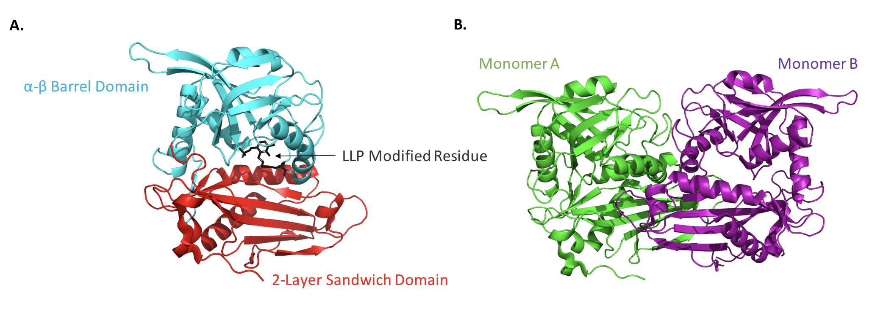

**Figure 2** Alignment of 7LV7 with eight structural homologs and the Conserved Regions. (A) Alignment of 7LV7 with the monomers of eight structural homologs. *Giardia lambia* is colored black and the other eight homologs are shown in various colors. *Streptococcus mutans* is colored red, *Deinococcus radiodurans* is colored blue, *Pseudomonas putida* is colored brown, *Mycobacterium tuberculosis* is colored green, *Homo sapiens* mitochondrial is colored orange, *Archaeoglobus fulgidus* is colored teal, *Escherichia coli* is colored olive, *Thermoproteus Uzoniensis* is colored purple. (B) Most Conserved Regions between Structural Homologs. Residues numbers 223-232 and 296-307 are labeled as regions 1 (red) and 2 (blue), respectively, in pymol cartoon form. These regions are the two most conserved regions of *Giardia lamblia* compared to its structural homologs and are located near the modified residue LLP. (C) Identical Residues between Structural Homologs and *Giardia lamblia* BCAT. The amino acid sequences for both regions are also shown, and the amino acids shared by *Giardia lamblia* and at least one other structural homolog are colored in red. (D) Number of Structural Homologs with Identical Residues in Regions 1 and 2. Region 1 is colored in red and Region 2 is colored in blue. The greater the number of structural homologs with identical amino acids for a residue number, the higher level of conservation is for that residue number.

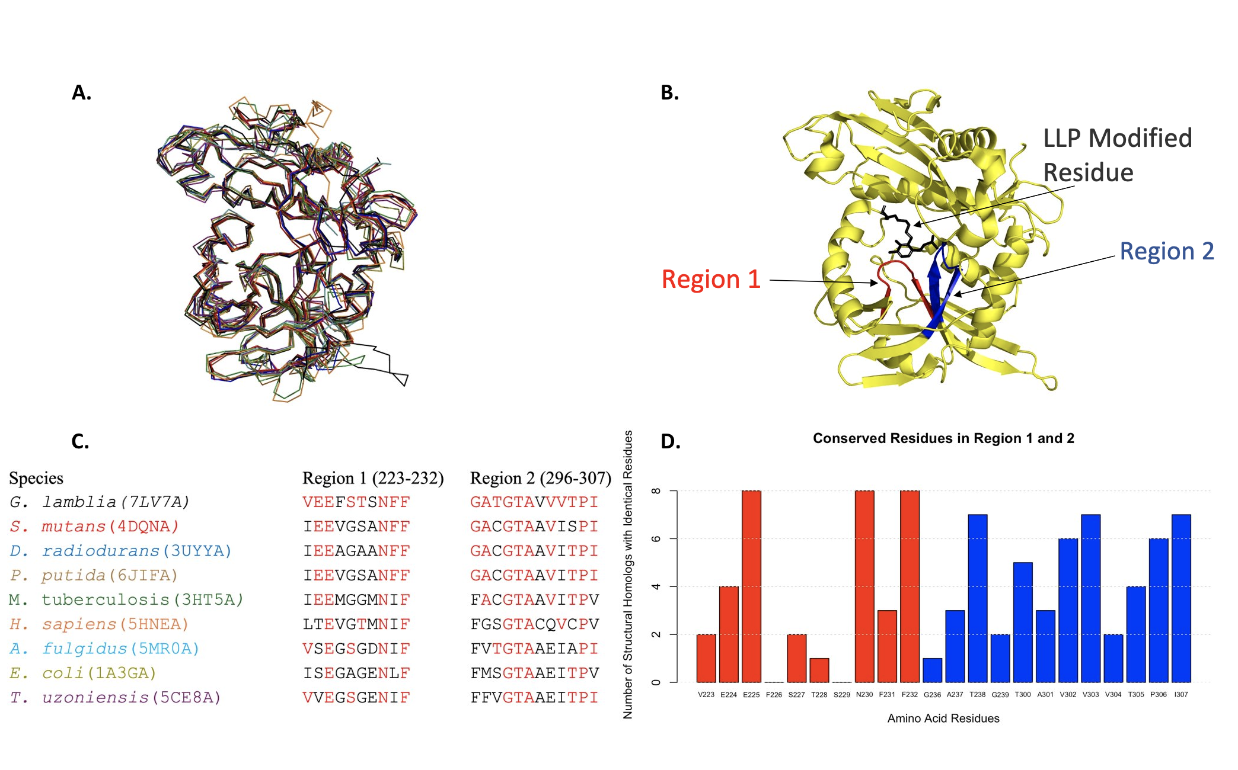

**Figure 3** Critical ligand PLP binds to 7LV7 near active site (A) Zoomed out view of 7LV7 with the PLP ligand colored in purple, contrasted with the rest of the protein in gray. (B) Zoomed in view of PLP ligand with hydrogen bonding interactions with itself and rest of 7LV7 protein. PLP is bonded to the lysine at residue 187 to form LLP. Residues which experience hydrogen bonds with PLP have been colored in red, which are T261, I260, F60, G297, R84, T298, S259, Y192, and S88. Note that T298 is not visible in image and is behind cluster of residues just beneath T261 and I260.

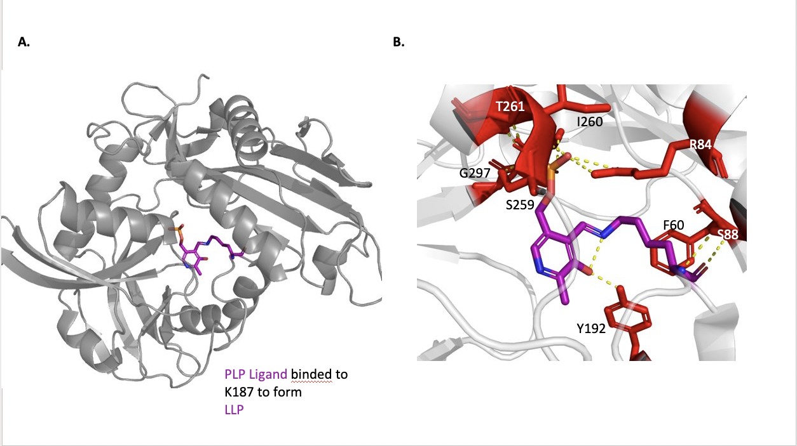

**Figure 4** Docking of BAY-069 Inhibitor into active site of 7LV7(A) 7LV7 is colored in light gray while literature supported active site inhibitor BAY-069 is colored in purple. Inhibitor BAY-069 occupies the active site and does not allow for intended substrates (leucine, isoleucine, and valine) to bind to active site. View displays hydrogen bonding interactions between 7LV7 and BAY-069 as dashed yellow lines. Residues which experience hydrogen bonds with BAY-069 (Y127 and R129) have been colored in red

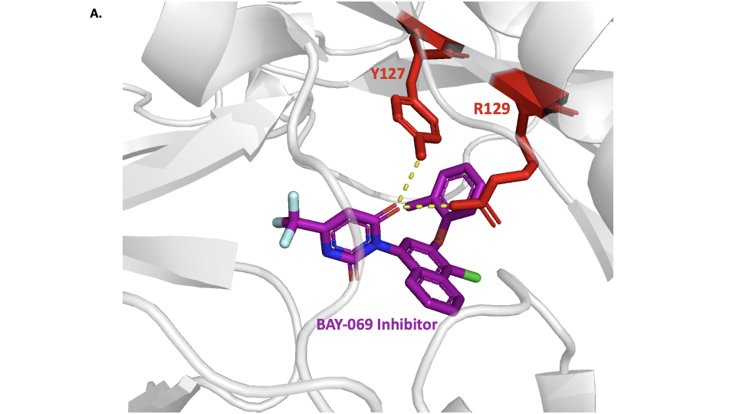

1. We would like to thank Jeffery Lotthammer and Jie Wang for their feedback in this paper. We are also grateful for the other teaching assistants and other students in the Bio 4525.

References

[Adam, R. D. (2001). Biology of Giardia lamblia. *Clinical Microbiology Reviews*, *14*(3), 447–475. https://doi.org/10.1128/CMR.14.3.447-475.2001](https://www.zotero.org/google-docs/?82AK2E)

[Capra, J. A., & Singh, M. (2007). Predicting functionally important residues from sequence conservation. *Bioinformatics (Oxford, England)*, *23*(15), 1875–1882. https://doi.org/10.1093/bioinformatics/btm270](https://www.zotero.org/google-docs/?82AK2E)

[Castell, A., Mille, C., & Unge, T. (2010). Structural analysis of mycobacterial branched-chain aminotransferase: Implications for inhibitor design. *Acta Crystallographica Section D: Biological Crystallography*, *66*(5), 549–557. https://doi.org/10.1107/S0907444910004877](https://www.zotero.org/google-docs/?82AK2E)

[Conners, E. E. (2021). Giardiasis Outbreaks—United States, 2012–2017. *MMWR. Morbidity and Mortality Weekly Report*, *70*. https://doi.org/10.15585/mmwr.mm7009a2](https://www.zotero.org/google-docs/?82AK2E)

[Dajnowicz, S., Parks, J. M., Hu, X., Gesler, K., Kovalevsky, A. Y., & Mueser, T. C. (2017). Direct evidence that an extended hydrogen-bonding network influences activation of pyridoxal 5’-phosphate in aspartate aminotransferase. *The Journal of Biological Chemistry*, *292*(14), 5970–5980. https://doi.org/10.1074/jbc.M116.774588](https://www.zotero.org/google-docs/?82AK2E)

[*Giardiasis: When it’s not safe to drink the water-Giardia infection (giardiasis) - Symptoms & causes*. (n.d.). Mayo Clinic. Retrieved April 10, 2024, from https://www.mayoclinic.org/diseases-conditions/giardia-infection/symptoms-causes/syc-20372786](https://www.zotero.org/google-docs/?82AK2E)

[Günther, J., Hillig, R. C., Zimmermann, K., Kaulfuss, S., Lemos, C., Nguyen, D., Rehwinkel, H., Habgood, M., Lechner, C., Neuhaus, R., Ganzer, U., Drewes, M., Chai, J., & Bouché, L. (2022). BAY-069, a Novel (Trifluoromethyl)pyrimidinedione-Based BCAT1/2 Inhibitor and Chemical Probe. *Journal of Medicinal Chemistry*, *65*(21), 14366–14390. https://doi.org/10.1021/acs.jmedchem.2c00441](https://www.zotero.org/google-docs/?82AK2E)

[Hajare, S. T., Chekol, Y., & Chauhan, N. M. (2022). Assessment of prevalence of Giardia lamblia infection and its associated factors among government elementary school children from Sidama zone, SNNPR, Ethiopia. *PloS One*, *17*(3), e0264812. https://doi.org/10.1371/journal.pone.0264812](https://www.zotero.org/google-docs/?82AK2E)

[Han, J., & Collins, L. J. (2012). Reconstruction of Sugar Metabolic Pathways of Giardia lamblia. *International Journal of Proteomics*, *2012*, 980829. https://doi.org/10.1155/2012/980829](https://www.zotero.org/google-docs/?82AK2E)

[Holm, L. (2020). DALI and the persistence of protein shape. *Protein Science*, *29*(1), 128–140. https://doi.org/10.1002/pro.3749](https://www.zotero.org/google-docs/?82AK2E)

[Hutson, S. (2001). Structure and function of branched chain aminotransferases. *Progress in Nucleic Acid Research and Molecular Biology*, *70*, 175–206. https://doi.org/10.1016/s0079-6603(01)70017-7](https://www.zotero.org/google-docs/?82AK2E)

[Liu, Y., Yang, X., Gan, J., Chen, S., Xiao, Z.-X., & Cao, Y. (2022). CB-Dock2: Improved protein-ligand blind docking by integrating cavity detection, docking and homologous template fitting. *Nucleic Acids Research*, *50*(W1), W159–W164. https://doi.org/10.1093/nar/gkac394](https://www.zotero.org/google-docs/?82AK2E)

[Percudani, R., & Peracchi, A. (2003). A genomic overview of pyridoxal-phosphate-dependent enzymes. *EMBO Reports*, *4*(9), 850–854. https://doi.org/10.1038/sj.embor.embor914](https://www.zotero.org/google-docs/?82AK2E)

[Roura Padrosa, D., Alaux, R., Smith, P., Dreveny, I., López-Gallego, F., & Paradisi, F. (2019). Enhancing PLP-Binding Capacity of Class-III ω-Transaminase by Single Residue Substitution. *Frontiers in Bioengineering and Biotechnology*, *7*, 282. https://doi.org/10.3389/fbioe.2019.00282](https://www.zotero.org/google-docs/?82AK2E)

Soderberg, Timothy, "Organic Chemistry with a Biological Emphasis Volume I" (2019). *Chemistry Publications*. 1.

<https://digitalcommons.morris.umn.edu/chem_facpubs/1>

[Tremblay, L. W., & Blanchard, J. S. (2009). The 1.9 A structure of the branched-chain amino-acid transaminase (IlvE) from Mycobacterium tuberculosis. *Acta Crystallographica. Section F, Structural Biology and Crystallization Communications*, *65*(Pt 11), 1071–1077. https://doi.org/10.1107/S1744309109036690](https://www.zotero.org/google-docs/?82AK2E)